**LEBANESE AMERICAN UNIVERSITY**

**USAID – HIGHER EDUCATION SCHOLARSHIP PROGRAM**

**HES - Volunteering Program Verification Form**

This form is to be used to document volunteering hours. If a student volunteers for multiple organizations, a separate form must be used for each organization. **This form must be turned in by the 28th of each month, the latest.**

I certify that the scholar Nireez Al Sweidan completed a total of 5 hours of service at InnovaThrive.

The hours were completed hours as per the below:

Hours # 0 (date) _2/12 – 6/12_ (initials of supervisor) __A.K.___

Hours # 0 (date) _9/12 – 13/12_ (initials of supervisor) __A.K.___

Hours # 5 date) _16/12 – 20/12 (initials of supervisor) __A.K.___

Hours # 0 date) _23/12 - 27/12 (initials of supervisor) __A.K.___

Brief description of the activities the scholar performed or participated in:

My research focused on using blockchain technology to secure supply chains in the pharmaceutical industry. Blockchain’s decentralized and immutable nature can address issues like counterfeit drugs, theft, and fraud by providing a transparent, tamper-proof record of every transaction along the supply chain. This ensures product authenticity and builds trust among stakeholders.  
  
I explored real-life examples of blockchain adoption by pharmaceutical companies, showing a reduction in counterfeit incidents. The advantages include improved traceability and security, while challenges include integration with existing systems and high implementation costs. Future research should focus on overcoming these barriers and expanding blockchain's role in global supply chain transparency.

Written feedback about the scholar’s performance:

Nireez explored blockchain in securing pharmaceutical supply chains, highlighting its role in combating counterfeit drugs. She effectively addressed both the benefits and challenges of integrating blockchain into existing systems.

Please rate the overall performance of the scholar at your organization:

|  |  |  |  |
| --- | --- | --- | --- |
|  | Mastery (5) | Proficient (3) | Emerging (1) |
| **Problem solver** | X |  |  |
| **Engaged & Committed** | X |  |  |
| **Open-minded & multicultural** | X |  |  |

Signature

& stamp

__________________________

_

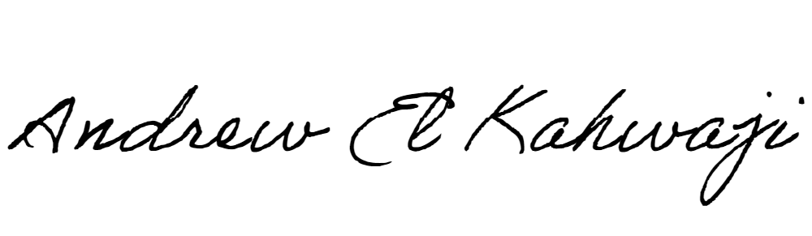

Printed Name _Andrew El Kahwaji_

Date __26/12/2024___

Email __andrew.lifesculptor.coo@gmail.com __

Phone __+961 71 914 378__